**Cricket**

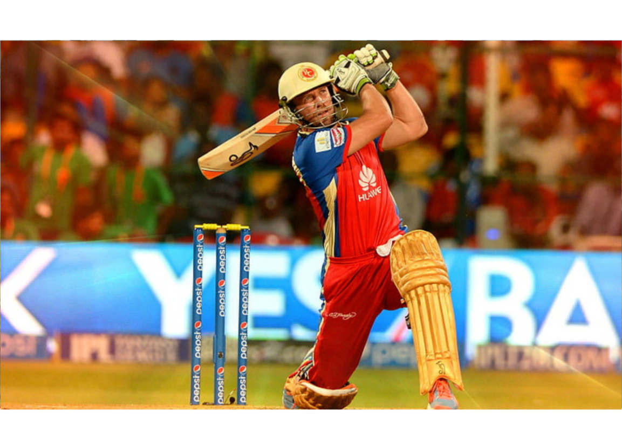

**Description**: A bat-and-ball game where teams take turns batting and fielding, aiming to score runs and dismiss opponents.

**How to Play**: One team bats while the other fields. The batting team scores runs by hitting the ball and running between wickets. The fielding team aims to dismiss the batsmen.

**Location**: Cricket pitch.

**Things Needed**: Cricket bat, ball, wickets.

**Players**: 11 per team.